Practical - 2
Practical Title: Semantic HTML5 Pages with Accessibility-Ready Structure
Problem Definition 1:Develop static HTML5 skeletons for at least 10 StudentHub pages such as: Home, About, Register, Login, Dashboard, Events, Profile, Contact,Admin, FAQ, and Feedback. Use semantic tags and accessibility-friendlystructure.
Theory
1: Are semantic tags such as header, nav, main, section, article, aside, and
footer used properly?
Answer: Yes.

2: Are form labels, headings, image alt text, and navigation links
accessible?
Answer:Yes.

3. Is the page structure consistent across all pages?

Answer: Yes because I used auto margin option.

Implementation/Output/Result(Keep only one option which is suitable to practical)
HTML Tags Summary
Across all provided files, the following HTML tags are used:
- Document Structure:<!DOCTYPE html>, <html>, <head>, <title>, <meta>, <body>, <footer>, <style>
- Text & Layout Content:<h1>, <h2>, <p>, <hr>, <div>, <br>
- Links & Media:<a>, <img>
- Tables:<table>, <tr>, <th>, <td>
- Forms & Interactive Elements:<form>, <label>, <input> (text, password, date, file), <select>, <option>, <button>
- Evidence of Work (Screenshots):HTML SCREENSHOTS:
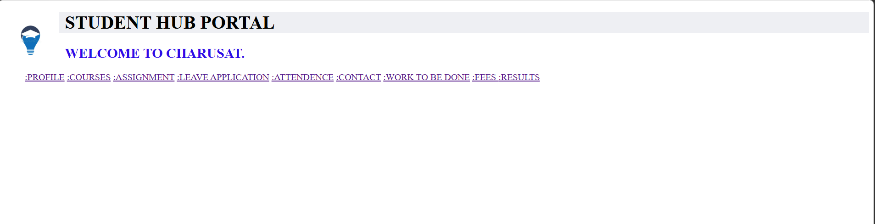
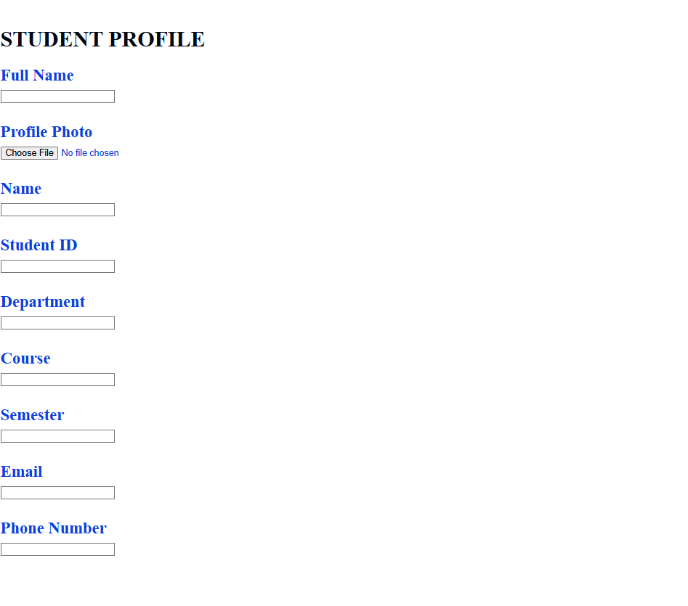
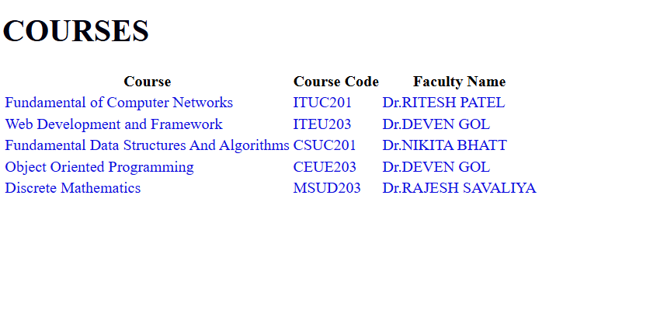

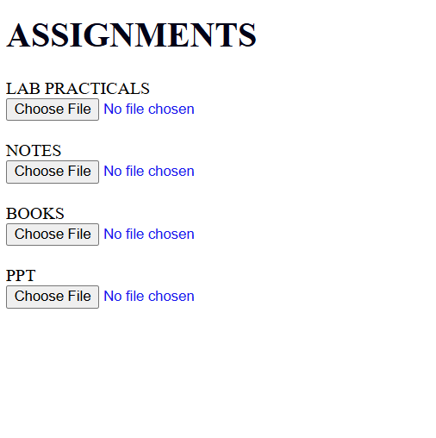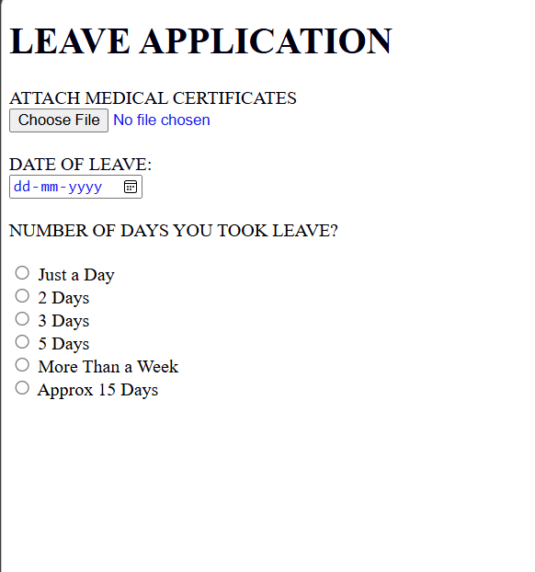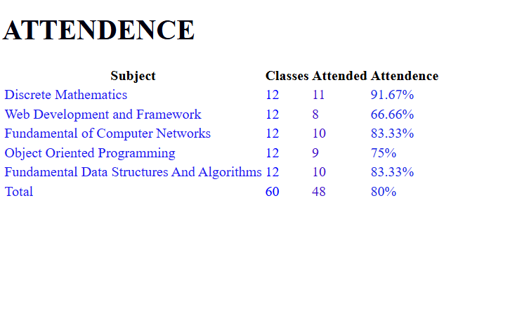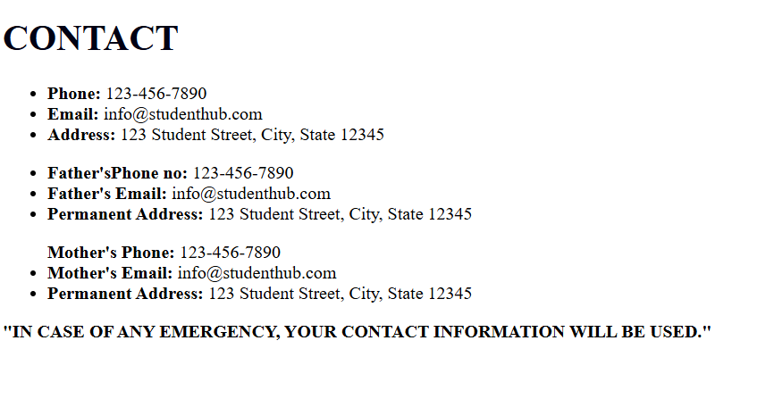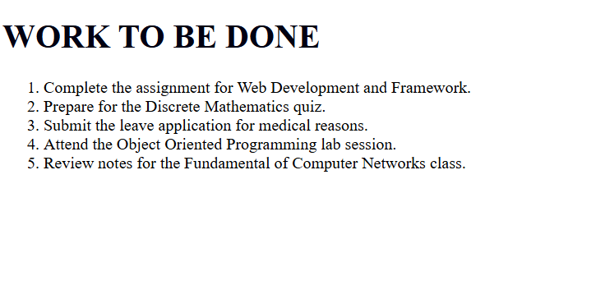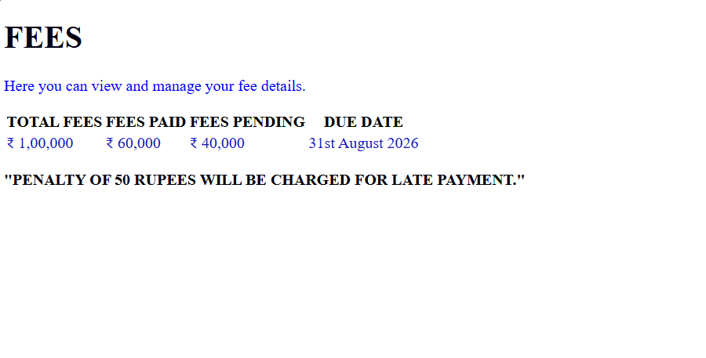

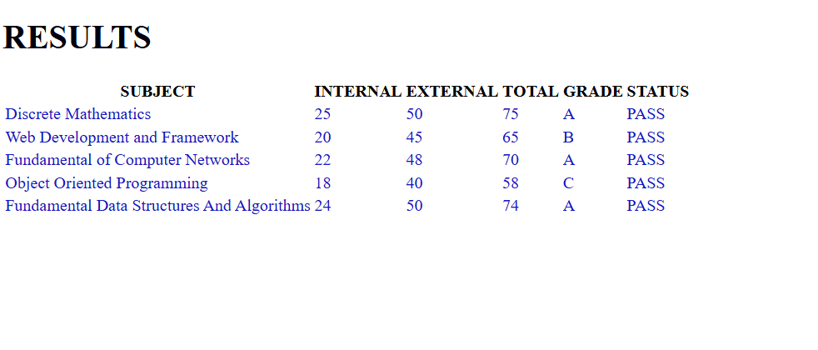

GitHub Repository Link:
https://github.com/25dce026-krishna/studenthub.git

Challenges Faced:
GITHUB REPO. CREATION,FOLDER CREATION,FILE CREATION.
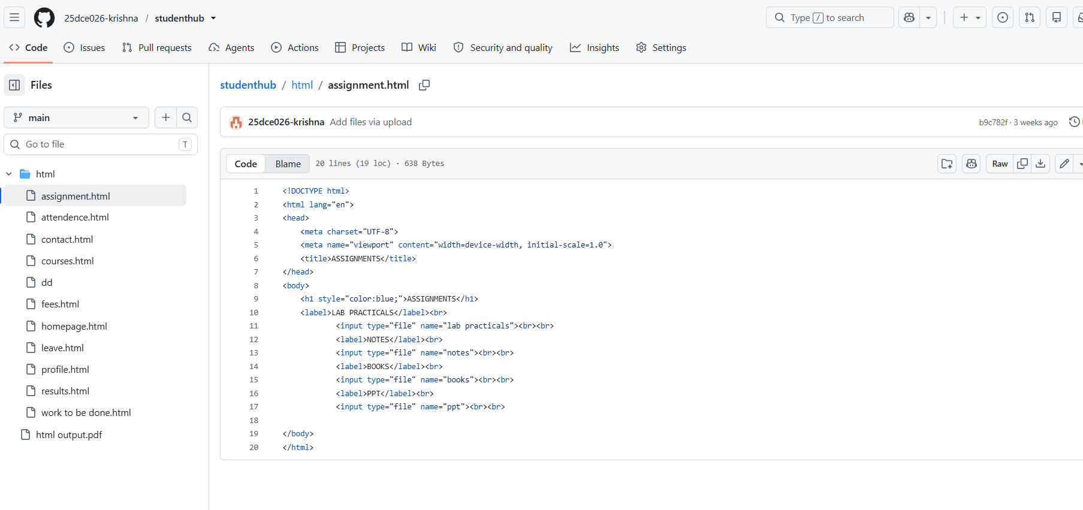
VSCODE FOLDER,FILE CREATION.
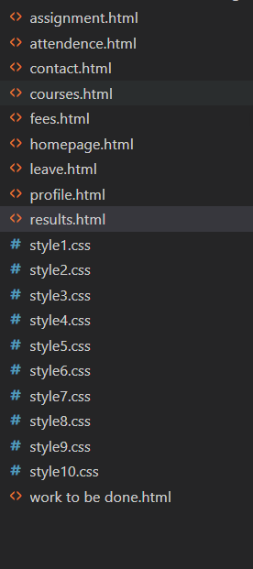

Learning Outcomes:

I LEARNED WEBSITE CREATION, SITEMAP, WIREFRAME, GITHUB, REQUIREMENT ANALYSIS, HTML, FILE MANAGEMENT

Faculty Remarks: (Keep this blank for faculty)

